Indoor Experiment Workflow

Lab
- Connection
  - Connect the FSC-UTIAS laptop to Helson’s Wi-Fi.
  - Power on the Orin (make sure it is also connected to Helson’s Wi-Fi), then connect to it via SSH in VS Code.
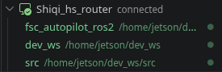
- Test the Micro XRCE-DDS Agent
  - cd ~/dev_ws/src/fsc_autopilot_ros2
./scripts/indoor_exp/start_microxrce_agent.sh
  - ros2 topic hz /uav_0/fmu/out/sensor_combined
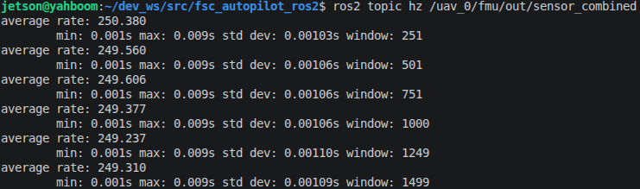
  - ros2 topic hz /uav_0/fmu/out/vehicle_attitude
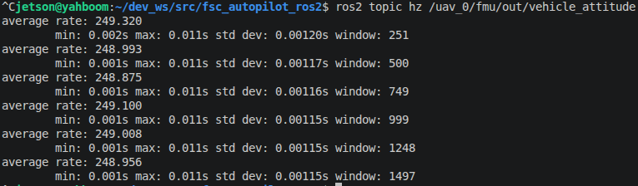
  - Verify the topic frequencies on the laptop as well.
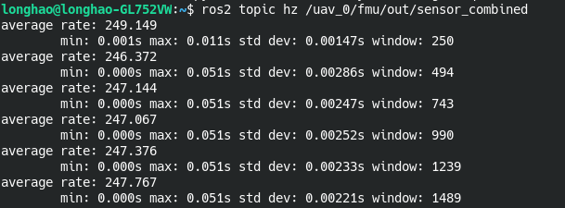
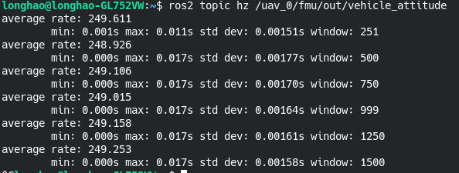
- After stopping the MicroXRCEAgent, reboot PX4 through QGroundControl.

[Orin]
- ~/dev_ws/src/fsc_open_manipulator/scripts/indoor_exp/start_open_manipulator_inverted_position.sh --no-gui
[Laptop - Shiqi ThinkPad]
- ~/ros2_ws/src/fsc_open_manipulator/scripts/indoor_exp/start_ground_station_inverted.sh

- Build the packages
  - Build fsc_autopilot_ros2
cd ~/dev_ws
colcon build --packages-select fsc_autopilot_ros2
source install/setup.bash
  - Build fsc_autopilot_ros2 when the Orin does not have Internet access.
cd ~/dev_ws
colcon build --cmake-args -DBUILD_TESTING=OFF --packages-select fsc_autopilot_ros2
source install/setup.bash

Dome
- Connection
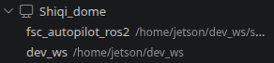
- [Laptop]
  - Start MOCAP
~/source/fsc_autopilot2_ws/src/fsc_optitrack_processor_ros2/scripts/launch_optitrack.sh 192.168.2.230 uav_0
  - Start the drone ground station
cd ~/source/fsc_autopilot2_ws/src/ros2_ground_station_gui && python3 src/single_drone_ground_control.py
  - Start the robotic arm ground station
source ~/fsc_autopilot_workspace/install/setup.bash
ros2 run custom_gui joint_plot_inverted --ros-args \
-r __ns:=/uav_0/fsc_open_manipulator \
-p torque_constant:=1.81 \
-p joint4_axis:="0 0 1"
- [Orin]
  - Start the MicroXRCEAgent
~/dev_ws/src/fsc_autopilot_ros2/scripts/indoor_exp/start_microxrce_agent.sh
  - Start the flight stack
~/dev_ws/src/fsc_autopilot_ros2/scripts/indoor_exp/start_geometric_direct_actuation_stack_t650.sh
~/dev_ws/src/fsc_autopilot_ros2/scripts/indoor_exp/start_geometric_direct_actuation_stack_t650_aerial_manipulator.sh
- Start the arm stack - position mode
~/dev_ws/src/fsc_open_manipulator/scripts/indoor_exp/start_open_manipulator_inverted_position.sh \
--no-gui namespace:=uav_0/fsc_open_manipulator
- Record a ROS 2 bag
ros2 bag record -o debug_recording_geometric_direct_$(date +%Y%m%d_%H%M%S) \
/uav_0/fsc_autopilot_ros2/position_controller/reference \
/uav_0/state_estimator/enu/imu/data \
/uav_0/state_estimator/local_position/odom \
/uav_0/state_estimator/local_position/optitrack_euler \
/uav_0/state_estimator/local_position/pixhawk_euler \
/uav_0/fmu/out/vehicle_attitude \
/uav_0/fmu/out/sensor_combined \
/uav_0/fmu/out/vehicle_status_v1 \
/uav_0/fsc_autopilot_ros2/geometric_direct_actuation/mode \
/uav_0/fsc_autopilot_ros2/controller_type \
/uav_0/fsc_autopilot_ros2/position_controller/state \
/uav_0/fsc_autopilot_ros2/position_controller/ude \
/uav_0/fsc_autopilot_ros2/attitude_controller/state \
/uav_0/fsc_autopilot_ros2/geometric_direct_actuation/geometric_control_debug \
/uav_0/fsc_autopilot_ros2/attitude_setpoint_debug \
/uav_0/fmu/in/vehicle_attitude_setpoint \
/uav_0/fsc_autopilot_ros2/geometric_direct_actuation/motors_debug \
/uav_0/fmu/in/actuator_motors \
/uav_0/fmu/in/vehicle_thrust_setpoint \
/uav_0/fmu/in/vehicle_torque_setpoint \
/uav_0/fmu/in/offboard_control_mode \
/uav_0/fsc_autopilot_ros2/vehicle_info \
/uav_0/fmu/out/vehicle_odometry \
/uav_0/fmu/out/estimator_status_flags \
/uav_0/fsc_open_manipulator/joint_states \
/uav_0/fsc_open_manipulator/position_controller/smoothed_reference_joint_trajectory

- Add the ROS 2 topics of the robotic arm.

Connect to the Orin via SSH:
- ssh jetson@192.168.50.107

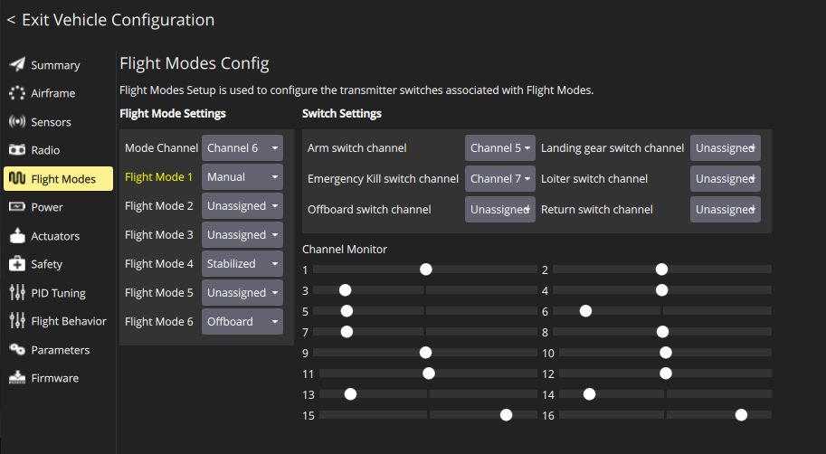

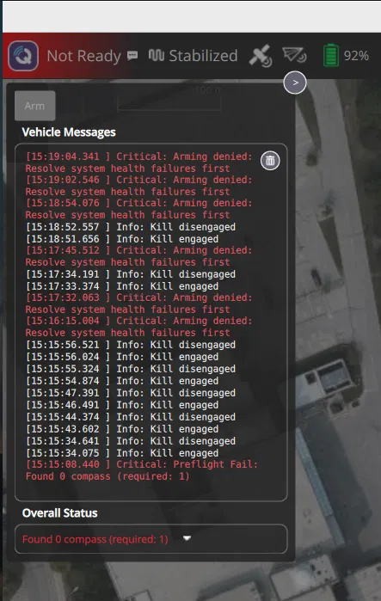

param set SYS_HAS_MAG 0
param save
reboot

